OS PROCESS CONCEPTS CODES AND OUTPUTS

1.Processed:
Code:
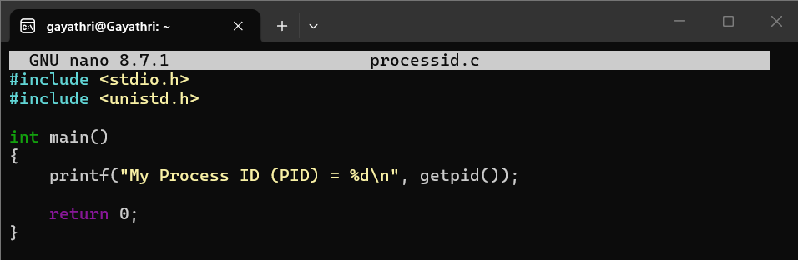

Output:
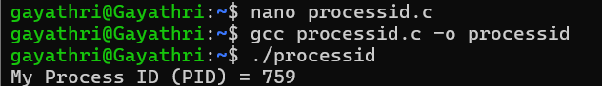

- creating child using fork()
Code:
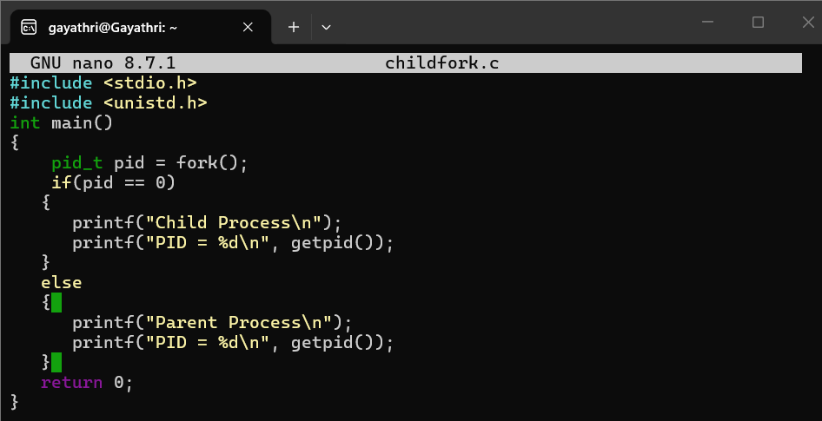
Output:
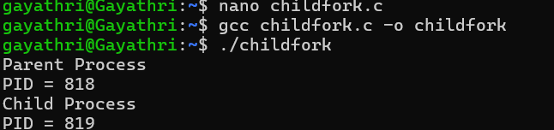
- Parent Waits for Child (wait())
Code:
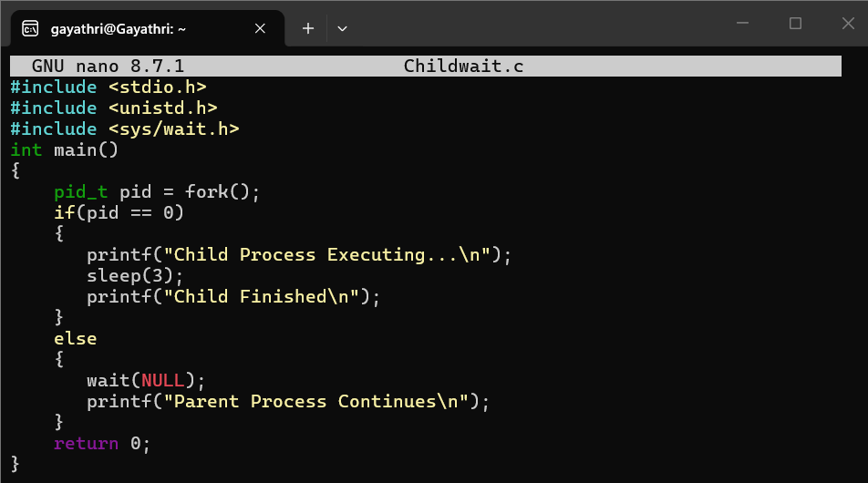

Output:
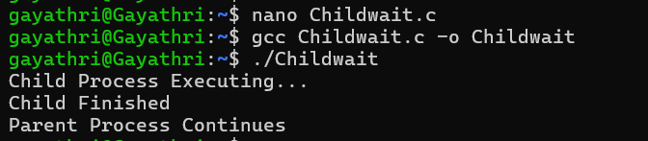

- Multiple Child Processes
Code:
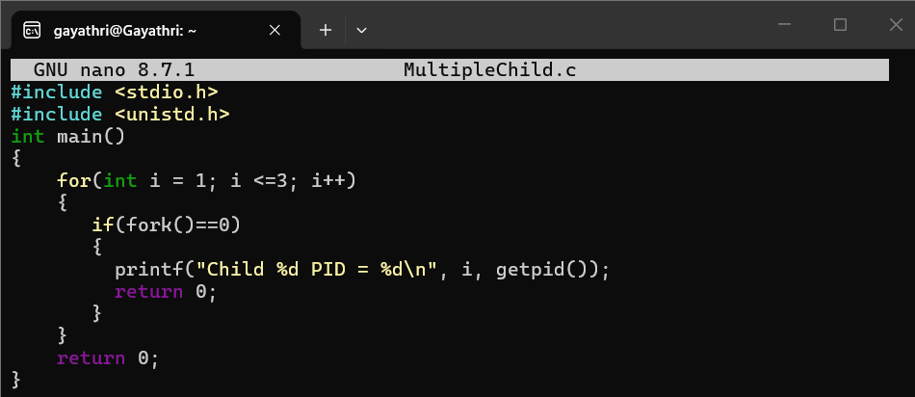
Output:
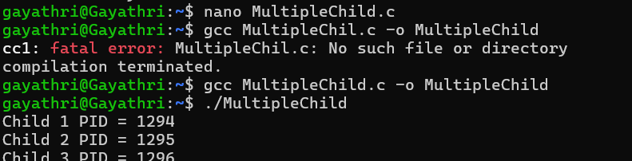

- Execute linux command using exclp()
Code:
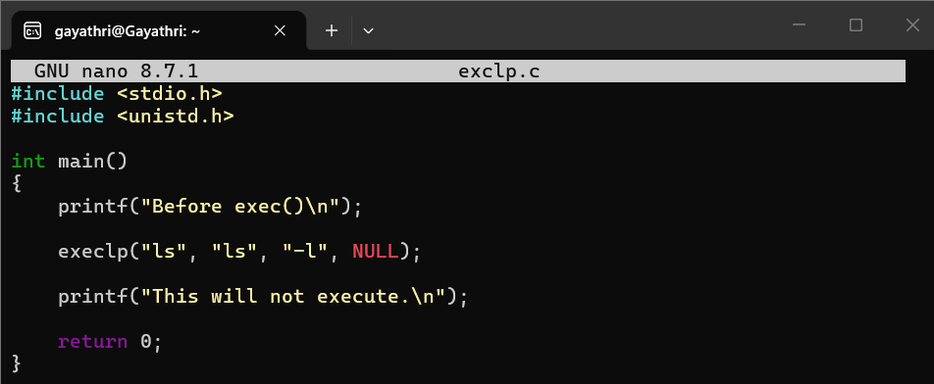
Output: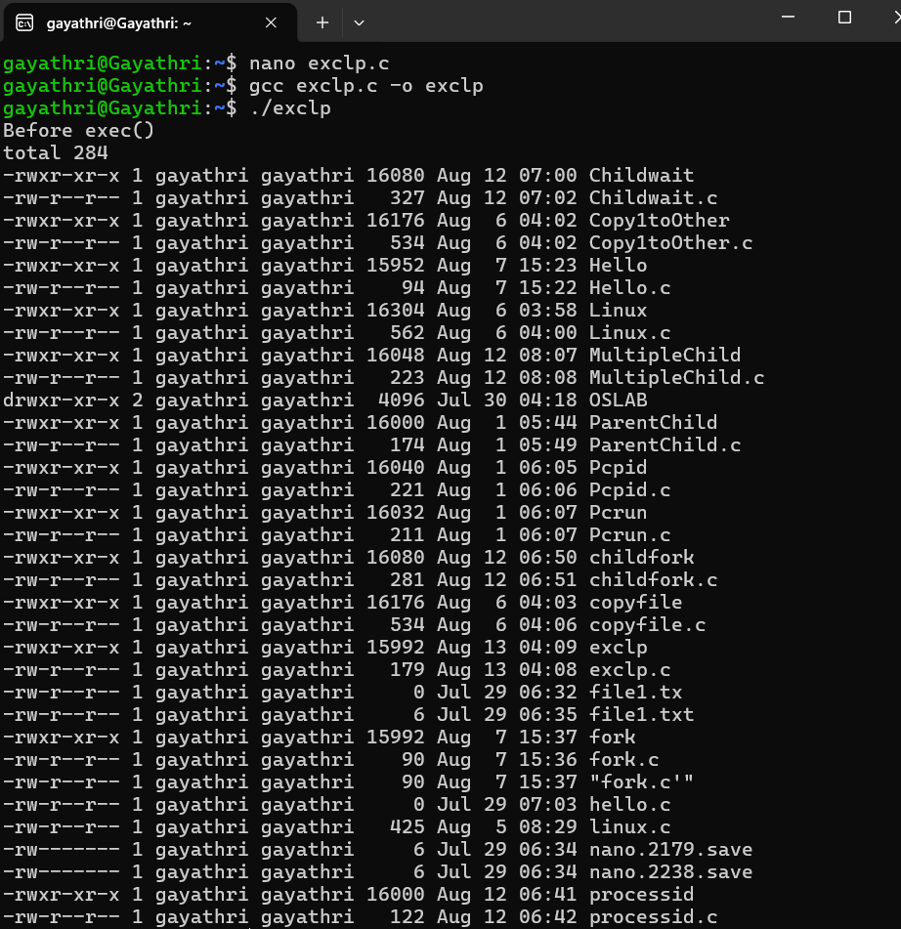

- Parent and Child Executing Concurrently
Code:
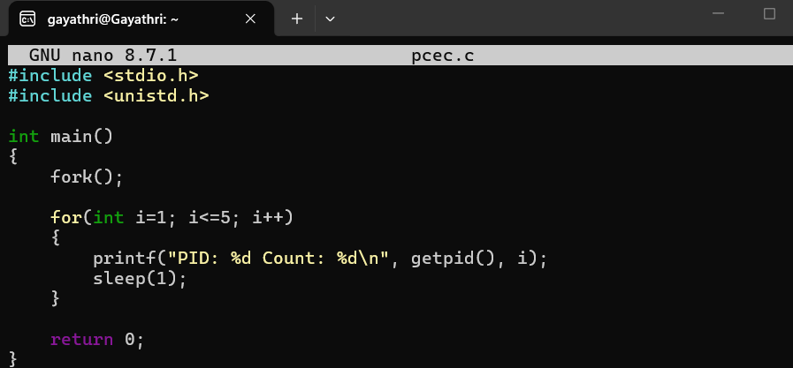
Output:
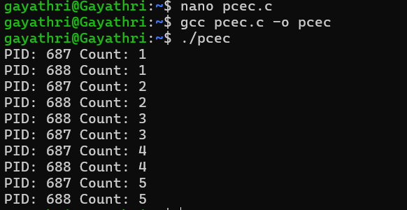

- Zombie Process
Code:
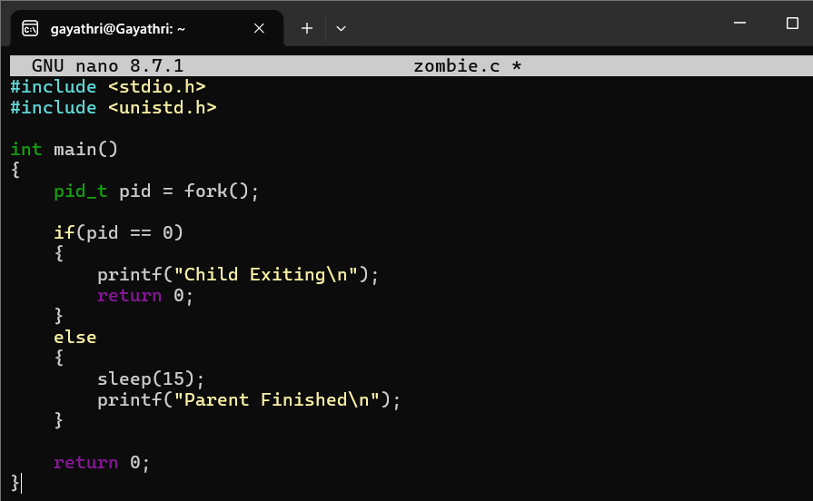
Output:
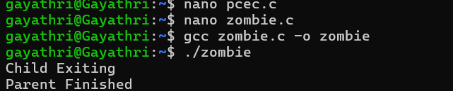

- OrphanProcess
Code:
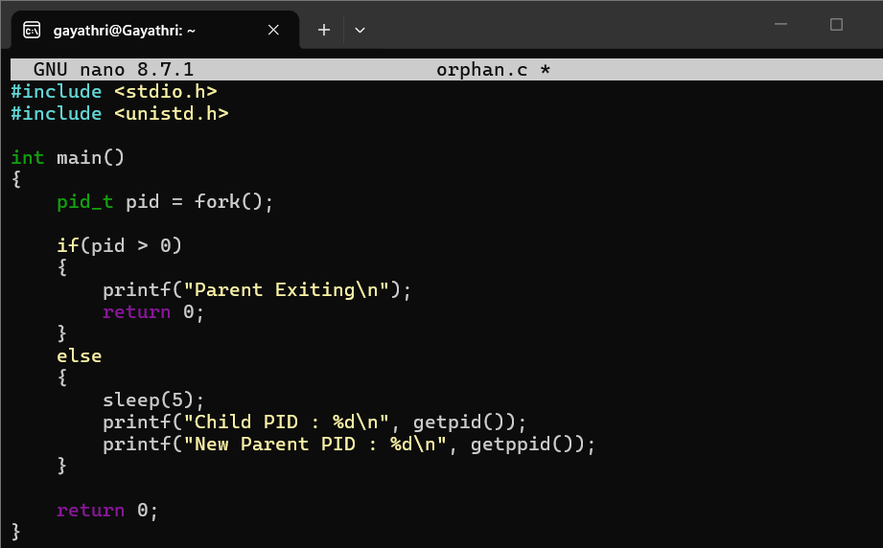
Output:
